PROJECT DEVELOPMENT PHASE DELIVERY OF SPRINT – 2

|  |  |
| --- | --- |
| **DATE** | **17.11.2022** |
| **TEAM ID** | **PNT2022TMID34348** |
| **TITLE** | **RETAIL STORE STOCK INVENTORY ANALYSIS** |

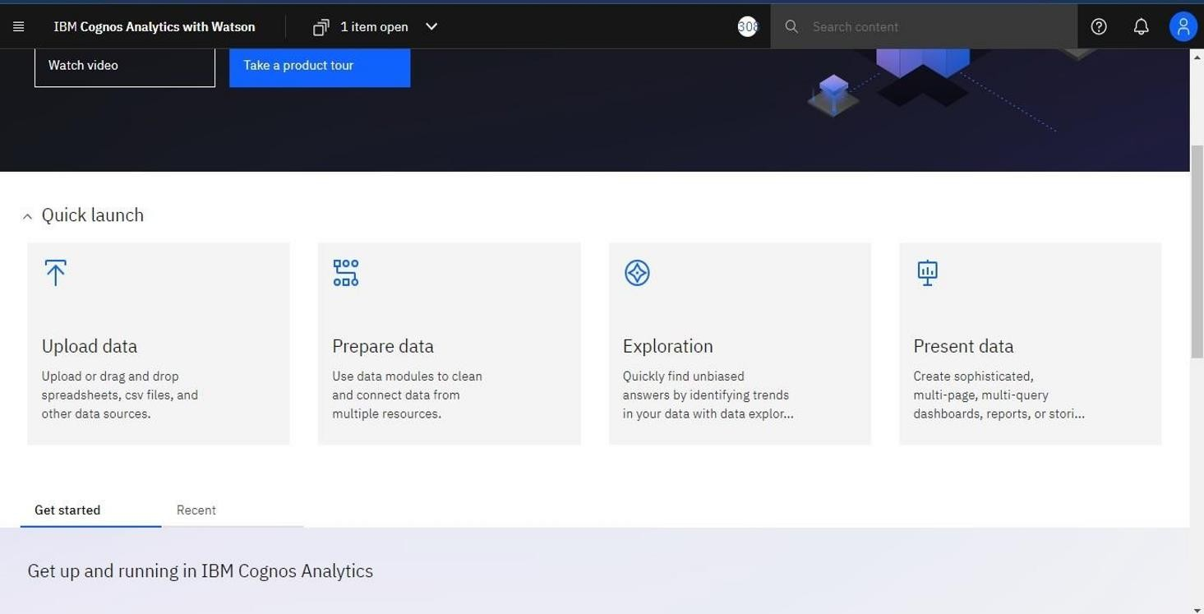

Year wise price using line graph:

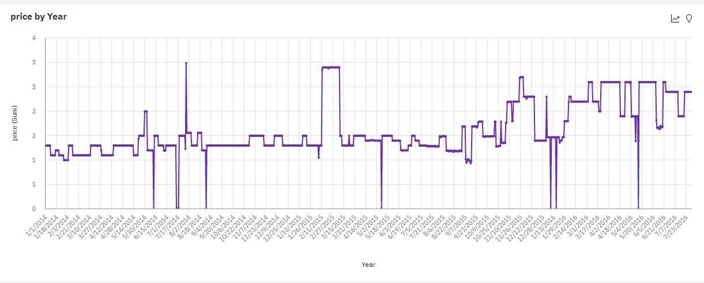

Year wise sales using line graph:

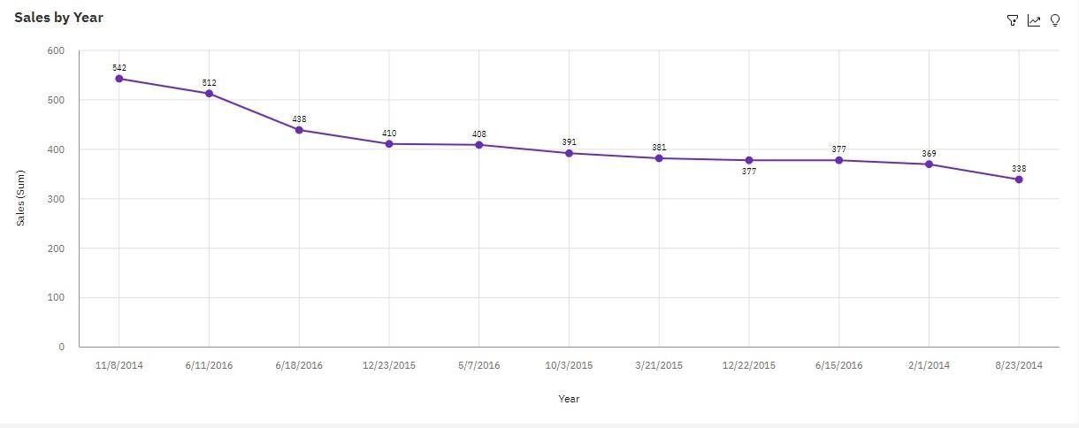

Top 10 sales by year using line graph:



Top 10 revenue by year using line graph:

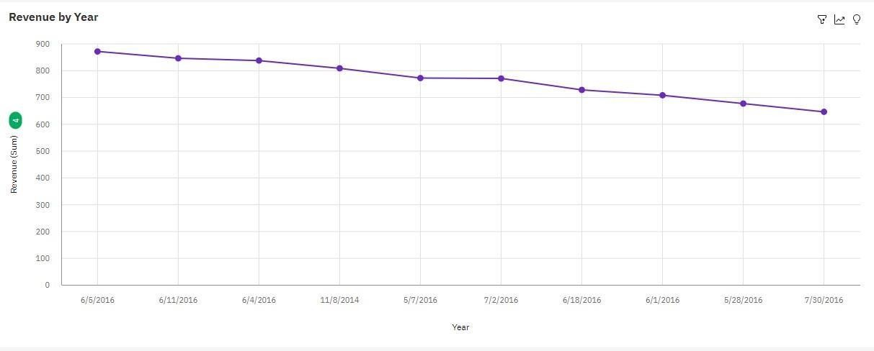

Monthly stock using heat map:

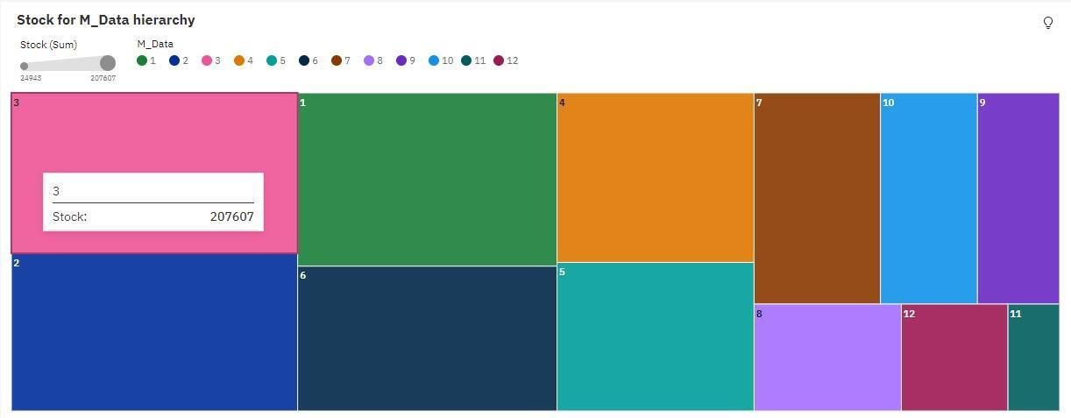

Monthly sales using tree map:

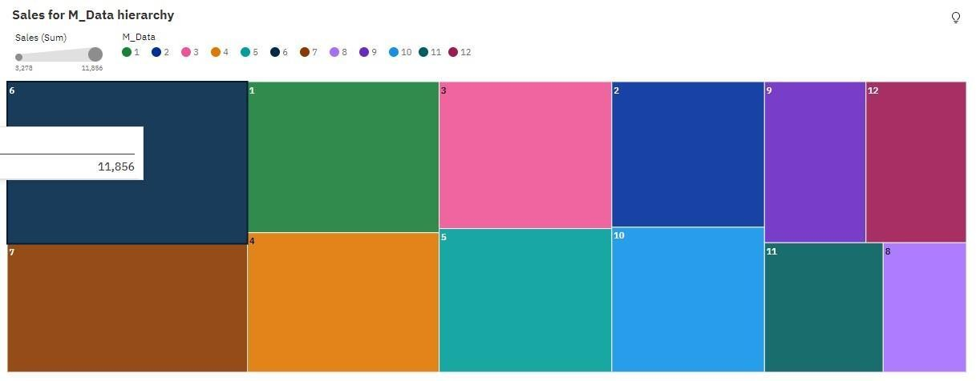

Monthly Revenue using pie chart:

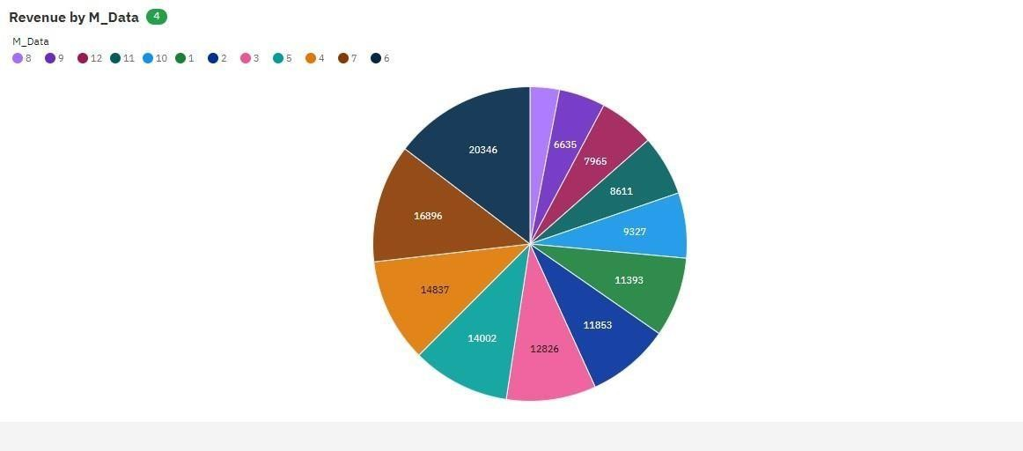

Total revenue summary card:

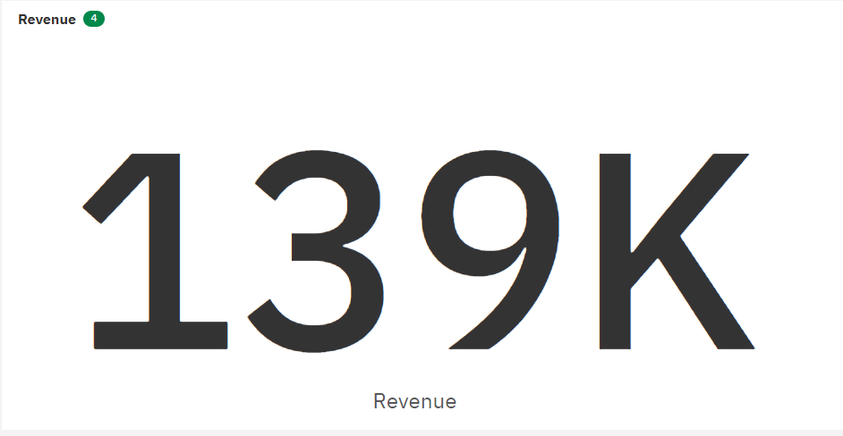

Total sales summary card:

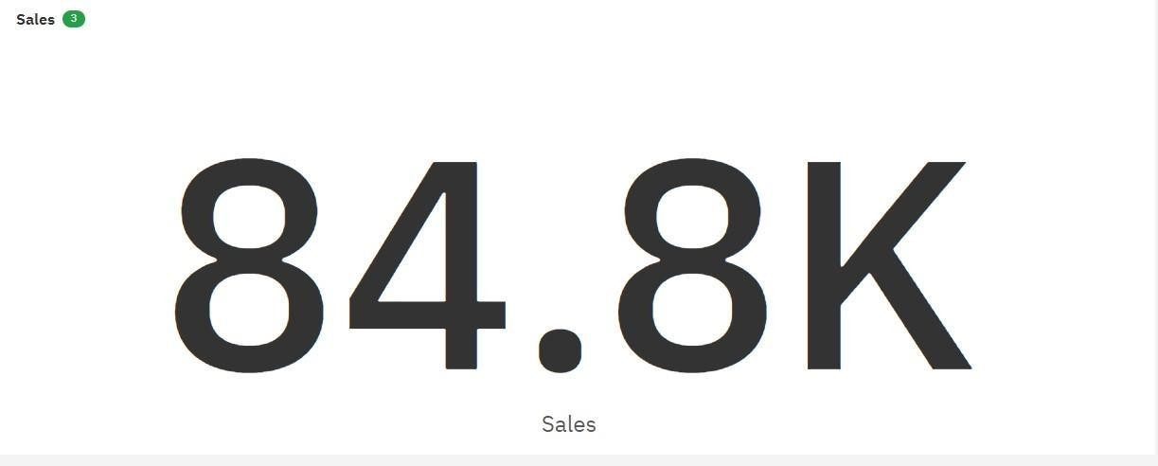

Total stock summary card:



Total price summary card:

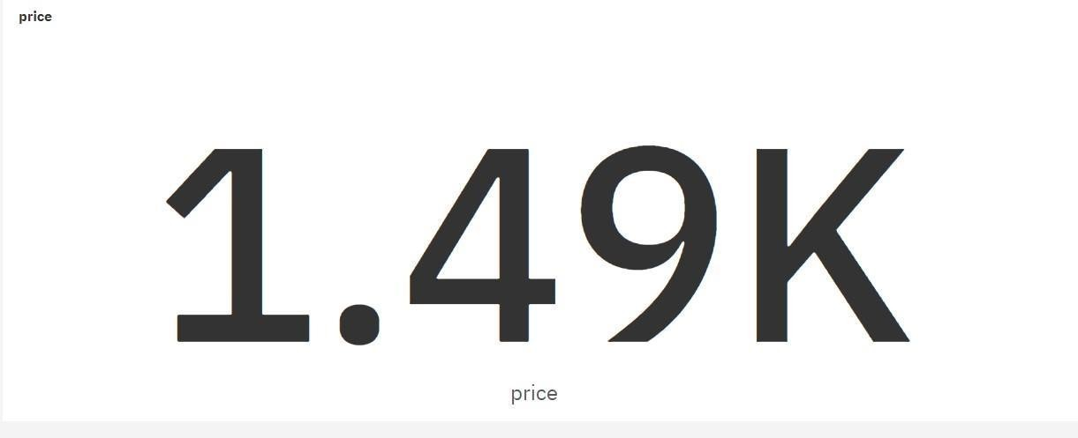

Dataset Link :[Inventory Management Dataset](https://drive.google.com/file/d/1TGCey9xTxKsg1g1g8H_Ym1QGblA_r0KK/view?usp=sharing)

Data Exploration link :

[https://us1.ca.analytics.ibm.com/bi/?perspective=explore&pathRef=.my_fo](https://us1.ca.analytics.ibm.com/bi/?perspective=explore&pathRef=.my_folders%2FRetailStoreStockInventoryExploration&subView=model000001844707feb0_00000003) [lders%2FRetailStoreStockInventoryExploration&subView=model00000184470](https://us1.ca.analytics.ibm.com/bi/?perspective=explore&pathRef=.my_folders%2FRetailStoreStockInventoryExploration&subView=model000001844707feb0_00000003) [7feb0_00000003](https://us1.ca.analytics.ibm.com/bi/?perspective=explore&pathRef=.my_folders%2FRetailStoreStockInventoryExploration&subView=model000001844707feb0_00000003)